**Project Design Phase-II**

**Data Flow Diagram & User Stories**

|  |  |
| --- | --- |
| Date | 20 October 2022 |
| Team ID | PNT2022TMID09796 |
| Project Name | Classification of Arrhythmia by Using Deep  Learning with 2-D ECG Spectral Image Representation |
| Maximum Marks | 4 Marks |

**Data Flow Diagrams:**

A Data Flow Diagram (DFD) is a traditional visual representation of the information flows within a system. A neat and clear DFD can depict the right amount of the system requirement graphically. It shows how data enters and leaves the system, what changes the information, and where data is stored.

**EXAMPLE:**

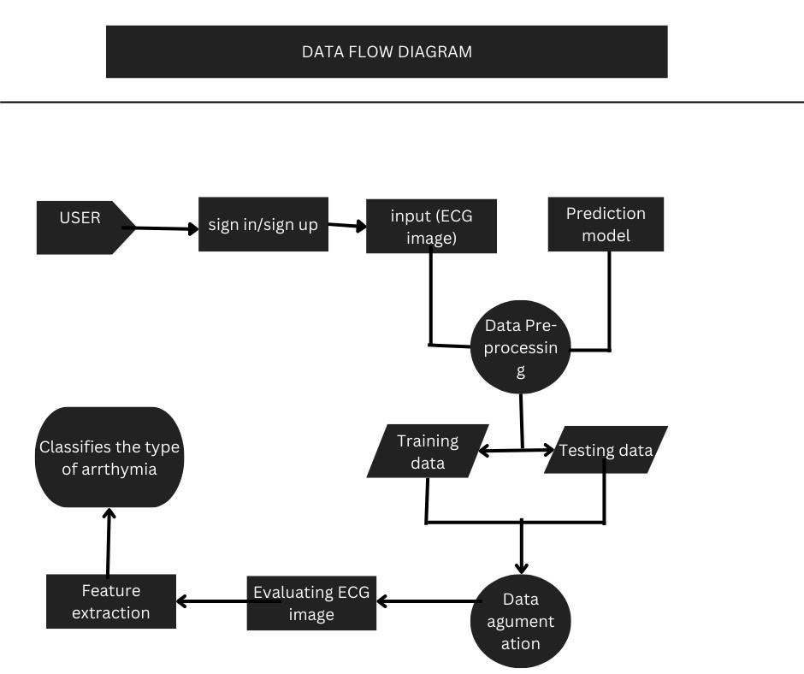

**User Stories**

Use the below template to list all the user stories for the product.

|  |  |  |  |  |  |  |
| --- | --- | --- | --- | --- | --- | --- |
| **User Type** | **Functional**  **Requirement**  **(Epic)** | **User**  **Story**  **Number** | **User Story / Task** | **Acceptance criteria** | **Priority** | **Release** |
| Customer (Mobile user) | Registration | USN-1 | As a user, I can register for the application by entering my email, password, and confirming my password. | I can access my account / dashboard | High | Sprint-1 |
|  | Confirmation | USN-2 | As a user, I will receive confirmation email once I have registered for the application | I can receive confirmation email & click confirm | High | Sprint-1 |
|  | Login | USN-3 | As a user, I can log into the application by entering email & password |  |  |  |
|  | Input | USN-3 | As a user, I can upload ECG image into the websites | Input for the model | Low | Sprint-2 |
|  | Dashboard | USN-4 | As a user I can classify the type of Arrhythmia from the output | Output for the model | Medium | Sprint-1 |